Unit 5 Day 1

Today, we are going to learn about parts and coverings on animals.

What do I know about animals? I know that some animals have…

Ears Legs Eyes

Mouth Arms Tail

Listen to this poem, it is called Legs.

Flamingos have legs, And alligators do, too.

Alligators have four legs, But flamingos have two!

People have parts such as a mouth, eyes, arms, and legs. Our bodies have coverings like hair and skin. Animals have parts and coverings too!

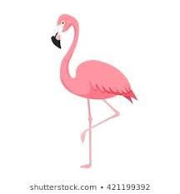Parts Flamingo Coverings

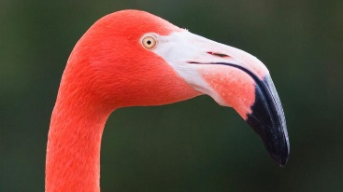

Beak Feathers

A beak is a part on a flamingo they use to eat! Flamingos use feathers as a covering too!

Alligator

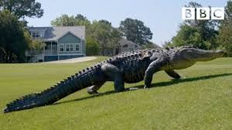Tail

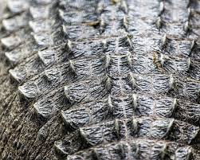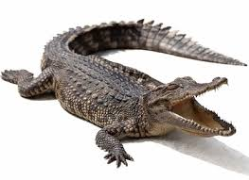Parts Coverings

Mouth Scales

A mouth and tail are two parts of an alligator and it uses scales as a covering!

If we compare a flamingo and an alligator, what do they both have?

How is a flamingo and alligator different from each other?

Activities! You are welcome to do all of these activities but please do at least three of them.

1. Have your child pick two animals and write what both animals have in common. They might need a visual model which means you have to write what they say first and then let them copy what you wrote.
2. Have your child write the words (and, but, too) 10 times each.
3. Have your child draw his or her favorite animal and label the parts and coverings it has.
4. Pick a number and have your child draw the different animals that has that number of legs. For example, if the number is 2, you child can draw a picture of a flamingo, a bird, a duck, a chicken, etc.
5. Have your child practice these simple sight words 5 times each (animal, eye, farm, different, all). This means to say the word, have the child say the word, and write the word.